PS2 Controller with Arduino – Connection Notes
Aim
To interface a PS2 (PlayStation-2) controller with Arduino in order to read button inputs and joystick values.

Components Required
- Arduino UNO / Nano
- PS2 Controller
- PS2 Wireless Receiver (9-pin)
- Jumper Wires
- USB Cable

PS2 Receiver Pin Description
Pin Name | Function
VCC | Power supply
GND | Ground
CLK | Clock signal
CMD | Command signal from Arduino
ATT / CS | Attention / Chip Select
DAT | Data signal to Arduino

Arduino Pin Configuration (According to Code)
ps2x.config_gamepad(10, 12, 11, 13, false, false);
PS2 Receiver Pin | Arduino Pin
CLK | Digital Pin 10
CMD | Digital Pin 12
ATT (CS) | Digital Pin 11
DAT | Digital Pin 13
VCC | 3.3V
GND | GND

Power Supply Note
The PS2 receiver works only at 3.3V.
Supplying 5V may damage the receiver permanently.

Connection Representation (Text Diagram)
PS2 Receiver to Arduino Connection
VCC → 3.3V
GND → GND
DAT → D13
CMD → D12
ATT → D11
CLK → D10

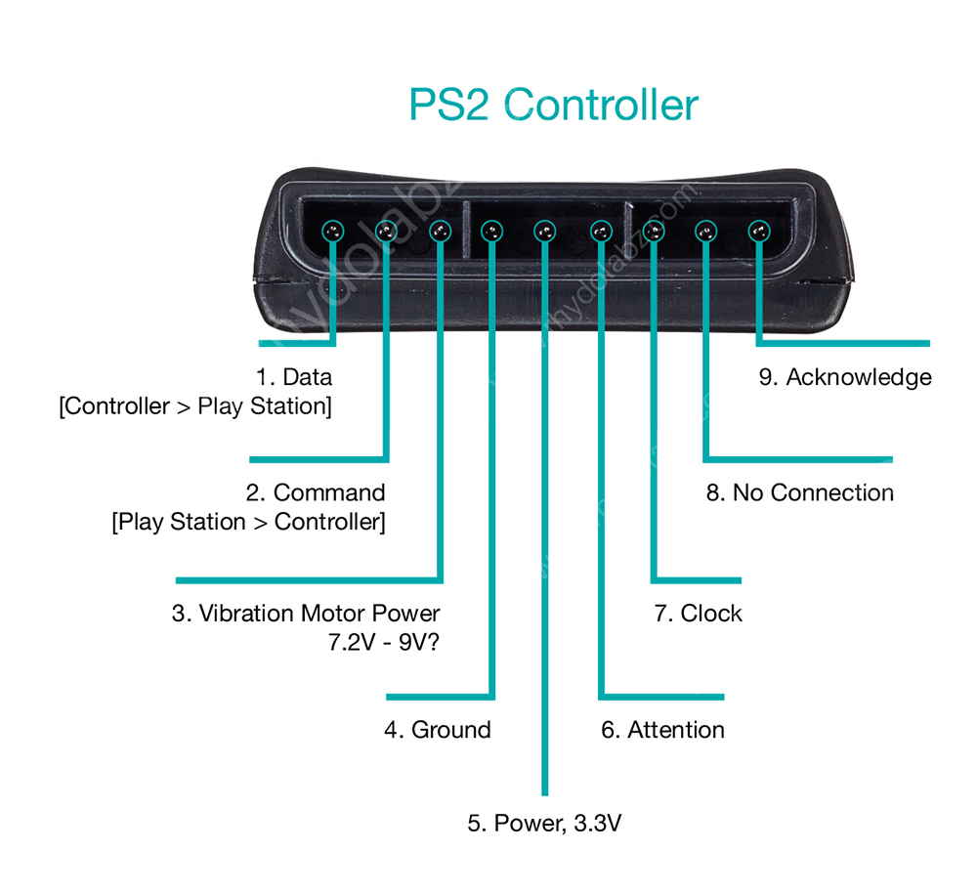

Working Principle
Communication between the Arduino and PS2 controller is based on a serial protocol.
Button presses generate digital signals.
Joystick movements generate analog values in the range of 0 to 255.
The ps2x.read_gamepad() function is used to read data from the controller.

Common Problems and Solutions
Problem | Possible Cause | Solution
Controller not detected | Incorrect wiring | Check all connections
Constant value 255 | DAT pin floating or loose | Fix DAT connection
No response | 5V supply used | Use only 3.3V
Random values | Loose jumper wires | Secure all wires

Testing Procedure
- Connect the PS2 controller to the receiver
- Upload the program to Arduino
- Open Serial Monitor at 115200 baud rate
- Press controller buttons
- Output will appear on the Serial Monitor

Applications
RC car control
Wireless robots
Joystick-based control systems
Game controller automation projects

Conclusion
The PS2 controller can be successfully interfaced with Arduino for wireless control applications. Proper wiring and correct voltage supply ensure reliable and stable operation.

30k --→ 25k
3hr – 2 days
Max – 50 – 60 student
1 group 5 student
12 something products minimum 3 months
Drones

